Ingrowth Core Processing Manual

Table of Contents
Flow Chart 2
Safety Hazards 3
Introduction 4
Sink Reservation Sign 5
Root Washing Methods 6
Sediment Sink Cleaning 10
Root Sorting Methods 11
Weighing Methods 15
Consolidating the Samples 17
Labeling Scintillation Vials 18
Grinding Methods 20
Tinning Ground Samples for CHN Protocol 22
Data Sheets, Checklists and Labels 26

File path for all things Root Wash Techs
S:\Biogeochemistry\GCREW\0-GCREW-Wide Data\Root Wash Techs

Flow Chart
Review this chart and read protocols for root washing and sorting. Watch the video that explains the root washing and sorting process. Examine the sorted roots standards that are preserved in scintillation vials.

Print out Checklists. These checklists will be used to help track ingrowth core processing.

Root Washing Root Sorting
Setup buckets inside sediment sink. Make sure drain plug and drain elevation tube are in place. Set up metal rack, bowl, and sieves.
Setup sorting area with coin envelopes, sharpies, a clear Pyrex dish filled with DI water and placed on a dark surface or tray (for contrast), a dispensing carboy filled with DI water (for refilling pan), forceps, and small scissors.

Examine the bag: look for holes, lack of peat, etc. and write a note on the checklist, if needed. Cut or disregard anything outside the bag. Cut bag in half and begin to wash the peat from the roots .
Open bag with root contents. Place of roots into the Pyrex dish. Thoroughly examine the bag to make sure nothing is left inside. Carefully sort roots identifying Fine Roots, C4 Rhiz, C3 Rhiz and Phrag Rhiz.

After roots have been washed and roughly sorted, rinse out the Ziplock bag (with the chamber and core label on it), gently place roots in a pile and then place them in this Ziplock bag.
Put sorted roots into coin envelope(s). Label with Year, Chamber #, Experiment, Core #, and Root or Rhizome type. Mark checklist with the date and your initials and put sample into the grieve oven.

Enter Dry Weight & Consolidate Samples
Take samples out of grieve oven and let sit for 20 minutes. During this time, use calibration weights to test the accuracy of the balance. Weigh each sample and write its’ weight into appropriate datasheet for each experiment. After weighing the sample, the sample may need to be consolidated. Reference individual experiments’ procedures for consolidation instructions.

Root Grinding
Follow the Grinding Procedures using the consolidated samples in the labeled coin envelopes.
Tinning Ground Samples for CHN
Follow the Tinning Procedures to microbalance samples using the ground samples in the labeled scintillation vials. These samples get sent to Suitland for CHN Isotope analysis.

Safety Hazards
Working in a standing position on a regular basis can cause sore feet, swelling of the legs, varicose veins, general muscular fatigue, low back pain, stiffness in the neck and shoulders, and other health problems.
Use rubber anti-fatigue mats for standing. It makes a big difference. Anti-fatigue mats absorb some of the shock due to standing for long periods of time and this cushioning effect reduces foot fatigue and other ailments. This may not eliminate sore feet by itself, but, when combined with proper work design and quality footwear, it should improve working conditions.

Introduction
Processing root ingrowth (below ground) biomass is an important part of most of the experiments at SERC’s Global Change Research Wetland. This manual contains instructions on the different stages of this process, delineates differences between experiments and provides insight to strategies and best practices.

Each experiment has an Ingrowth Root Biomass Tracking spreadsheet. It is important to make sure that these tracking spreadsheets are being updated as you move through the sample processing stages. Be sure to enter your progress in the appropriate tab for the specific census year. If a tab does not already exist for the Census year being processed, create a new tab.

Shortcuts to all of the ingrowth core tracking spreadsheets are available in the same Root Ingrowth folder as this procedures document: S:\Biogeochemistry\GCREW\0-GCREW Operations\GCREW Methods & Protocols\Root Ingrowth\Root Biomass Tracking. The actual files are in one folder in a different location:

1M: S:\Biogeochemistry\GCREW\0-GCREW-Wide Data\1-Sample Tracking\Root Biomass\1-CO2xComm (1 m) Root Ingrowth Tracking.xls
2M: S:\Biogeochemistry\GCREW\0-GCREW-Wide Data\1-Sample Tracking\Root Biomass\2-CO2xN (2 m) Root Ingrowth Tracking.xls
Phrag: S:\Biogeochemistry\GCREW\0-GCREW-Wide Data\1-Sample Tracking\Root Biomass\3-Phragmites Root Ingrowth Tracking.xls
SMARTX: S:\Biogeochemistry\GCREW\0-GCREW-Wide Data\1-Sample Tracking\Root Biomass\4-SMARTX Root Ingrowth Tracking.xls

Before you begin washing roots, make the SERC community aware that our Lab will be using Mathias Room 1029 for an extended period of time and give them an estimated time frame. This will allow you to work out any conflicts with using this space prior to starting. Create a sign using the template on the next page. This should be printed and hung on the entrance door and above each sink. At least one sink should be emptied and cleaned at the end of each day in case it is needed by someone else.

Sink Reservation Sign
Reserved

[start date] – [estimated end date]

While we process our annual root biomass, the Biogeochemistry Lab will be using both sinks daily.
We will make sure at least one sink is clean at the end of each workday so we can quickly make accommodations for anyone who may need to use a sink during this period.
If you would like to reserve time at a sediment sink during this timeframe, or have any questions, please contact:
Andrew Peresta x22446 perestaa@si.edu
or
Victoria Ellis x22257 ellisv@si.edu

Root Washing Methods
There are only two sinks in the Mathias Lab that can accept particles of any kind (i.e. sediment sinks). They are both located in Mathias 1029. Make sure that you sign out use of this space on ClusterMarket prior to your expected day(s) of use.
https://app.clustermarket.com/homepage?tab=calendar
The root washing process is easiest to understand visually so we’ve created a video that can be streamed on YouTube. Although the video does a good job explaining the process for which root cores are washed, there are strategies, best practices, and variables that make each experiment different from one another.
The video link for root core washing: https://www.youtube.com/watch?v=IX_sEKwUw7c
A three-person team is recommended. This will allow two people to be washing while the third is sorting, task rotation to break the monotony, and flexibility for team members to attend to any other tasks they may have. A two-person team will also work. Team members should agree on scheduling and sharing the tasks in a way that makes everyone comfortable and productive. Suggestions are: (1) washing in the morning and sorting in the afternoon or (2) one person washes while the other is sorting, with occasionally switching up to break up the monotony.
Materials: (for 2 root washers)
- Root cores
- (2) #18 sieves
- (2) #10 sieves
- (2) plastic bowls dark color
- (2) tweezers
- (2) scissors
- (2) long purple gloves
- (2) washing racks
- (2) buckets for under sediment trap
- (4) buckets for in sinks
- (1) used peat collection bin
- (2) plastic apron
- (1) checklist with clipboard and pen/pencil
- (2) rulers
Prior to Washing
- Receive required sediment sink training from Andrew Peresta or certified trainer.
- Print root washing checklist from server. This checklist will be used to document when and who washed each core.
  - Additional notes can be added to this checklist. For example: if a bag has been ripped, or if the peat has washed out, or any other abnormalities or observations.
Parent Filepath: S:\Biogeochemistry\GCREW\0-GCREW Operations\GCREW Methods & Protocols\Root Ingrowth\Checklist
LTREB File: S:\Biogeochemistry\GCREW\0-GCREW Operations\GCREW Methods & Protocols\Root Ingrowth\Checklist\Checklist for washing 1M 2M Phrag.xlsx
SMARTX FIle: S:\Biogeochemistry\GCREW\0-GCREW Operations\GCREW Methods & Protocols\Root Ingrowth\Checklist\GCREW SMARTX - checklist for root washing.xlsx
Workstation Setup
- Put the drain elevation tube into the middle drain of the sink.
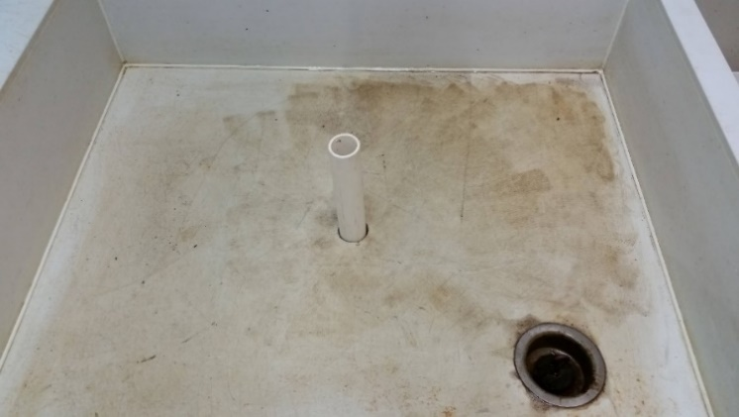
- Make sure black stopper is in the side drain or that the valve is closed. (Note: we typically keep the valve open because it is hard to twist open and closed)
drain elevation tube
stopper
- Put a bucket under the side drain/valve.
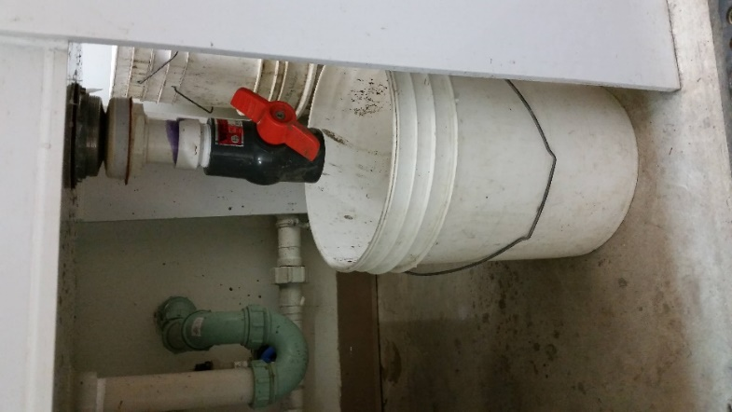
- Place two 5-gallon buckets in the sink and place the metal rack on top of them.
- Fill the buckets with enough water to prevent them from floating as the sink fills.
- Place the sieves (#10 on top, #18 on the bottom) on the metal rack above the first bucket. Place a big bowl (for sorting) on the rack above the other bucket.
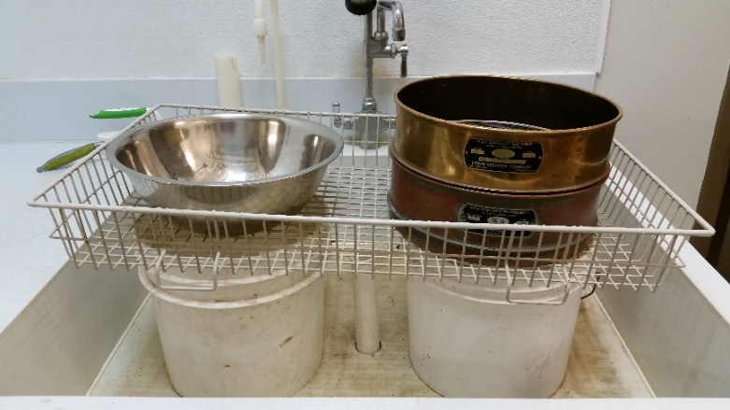

- Have a trash can next to the sink and a set of scissors and tweezers in your workstation.

Washing Protocol

- Transport root cores from cold storage to sediment sinks (room 1029) using a cart.
- Select a root core from the bin. The core will be in a Ziplock bag labeled with the experiment, chamber, and core number/letter. Remove core from Ziplock bag and place the core in the top sieve.
- Check the root core bag for any rips, holes, or other noteworthy things, and make a note of them in the washing checklist.
- Pick off any roots clinging to the outside of the plastic/mesh root core bag and discard into trash. Only the roots inside of the ingrowth core bag are of concern.
- Rinse out any loose dirt from the Ziplock bag and place it aside.
- Fill up your black plastic bowl of water and keep it next to your sieve.
- Different washing methods are required based on experiment
  - LTREB cores (1M, 2M, Phrag) - Cut the core in half and place one-half of the core into the top sieve. Spray the sediment through the sieves until mostly washed away. Then place the second half of the core into top of the sieve and repeat the process. Rinse core bag as well.
  - SMARTX cores (C3 & C4)- Separate each core into two (2) sections: the top 25 cm, and whatever amount is left at the bottom. Use a ruler and scissors to measure from the surface of the sediment down to 25 cm and cut the core there. The top 25 cm section of the core and the bottom remaining section of the core are now treated/processed as two separate cores. Use the gallon Ziploc (labelled “T”) for the top core roots, and large bag for the bottom core roots.
- Use tweezers to pick off any roots clinging to the outside and inside of the plastic/mesh root core bag(s). These roots should be saved and added to your pile of clean roots in the black plastic bowl of water.
  - You may encounter large rhizomes which can be tricky to remove from the mesh. You can use scissors to cut the mesh from around the rhizomes, if needed.
- Spray the sieve stack until most of the dirt/peat is washed through. Turning the sieve and spraying from an angle will help remove debris.
- Pick out as many roots as you can from the top and gently shake them in the bowl of water to remove debris. Pile the collected roots in the spout of the bowl. Transfer the pile to the Ziploc bag as needed when it becomes too large.

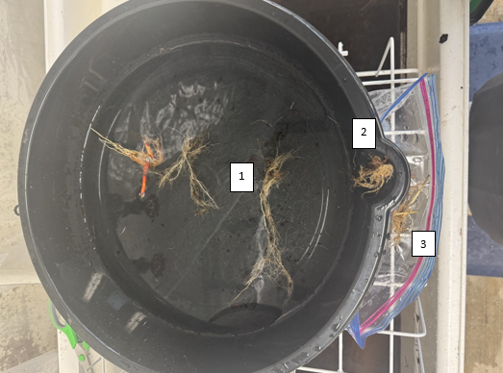
- Roots being swished around in water to remove debris
- Roots that are clean and waiting to be put into bag, this is especially helpful for tiny roots or ones that have broken apart. Large strings of roots can bypass this waiting point and be put directly in the bag.
- Roots that are clean and inside the sample bag

- Once you have removed the majority of the roots from the top side of the #10 sieve,
pick up the sieve to get a closer look. Holding it against the light/shadows will help to reveal more roots. Make sure to collect any roots stuck to the inner walls of the sieve. Flip the sieve over to find additional roots hanging on the underside.
Move any roots piled on the edge of the bowl into the Ziploc bag.
- Remove the top sieve from the bottom sieve and place it upside down inside of the bowl. Spray the sieve so all its contents land in the bowl. Submerging the roots in water will help remove any remaining peat. Remove the top sieve and recheck it for roots. Pick out the roots in the water and add to a new pile. The roots may or may not float.
- Rinse the bottom sieve. Pick out any roots that made it this far and add them to the pile.
- Use tweezers to remove the remaining roots from the bowl and place them in the Ziplock bag.
- Spray roots again until sufficiently cleaned. (“clean” is a judgement call; each core should take ~15-20 min). Use tweezers to move the roots back into the labeled Ziplock bag you placed aside earlier. It’s important that all the roots remain intact. Check the bottom of the top sieve and the contents of the bottom sieve for stray roots.
- If people are sorting roots at the same time, they will come in and grab the stack of Ziplock bags containing washed roots; if not, move the stack of Ziplocks into the cold room when you’re done at the end of each day.
- Washed roots waiting to be sorted should not be left in the freezer longer than a week; a good rule of thumb is to stop washing early enough on Friday that you can sort all remaining bags before leaving for the weekend.

Sediment Sink Cleaning

If possible, one of the sinks is cleaned at the end of each workday in case it is needed by another Lab. At a minimum, the sinks should be emptied once a week to limit buildup of peat. It is easier to empty the sinks if they are left overnight so that the peat settles to the bottom, but it can be done at any time.

Prior to Cleaning
- Rinse sieves and washing materials and remove the metal rack from the sink.
- Leave the drain elevation tube standing. Make sure there is a bucket under the side drain but do not remove the black stopper yet.

Cleaning Protocol
- Remove the buckets from inside of the sink. Slowly lift one bucket at a time, pouring the extra water from the bucket into the sink while keeping most of the peat inside the bucket. Place the bucket on a cart (for transport) and repeat this for the second bucket in the sink.
- Use your hand or a scooper to gently push the peat away from the base of the drain elevation tube. Then unscrew the tube and tilt it slightly to allow water to slowly drain.
- To avoid washing too much peat down the drain, allow most of the water to drain out slowly. When the water level is as low as possible and too “dirty” to continue draining, screw the drain elevation tube back in place.
- Make sure there is a 5-gallon bucket underneath the side drain valve. Remove the black stopper and use a scoop to push the peat through the valve opening and down into the bucket. You may also choose to scoop the peat directly into one of the existing waste buckets.
- When most of the peat is removed, use the spray nozzle to spray the remaining peat off the sides and bottom of the sink. Then use the squeegee to push everything into the bucket under the side valve.
- Replace the black stopper, remove the drain elevation tube, and rinse the sink again, allowing the water to flow down the main drain through the metal strainer drain insert.
- Using a cart, take all buckets of peat and wastewater outside to the sediment dumping site, then rinse buckets with the outside hose before returning them to the sediment sink room. The sediment dumping site is outside of the loading dock and to the left.
- A broom and dustpan should be available in room 1028 to sweep the workspace, including under the mats.

Leave the sinks, and workspaces, better than how you found them!

Root Sorting Methods
Root sorting is done in the Field Sample Processing Room, Mathias 1028. Make sure that you sign out a workstation in this room (on Cluster Market) prior to your expected day(s) of use. Volunteers are helpful in the sorting process. Reach out to the volunteer coordinator to request a volunteer, if needed. If volunteers are assisting, always have one trained person available (either in the room sorting with them or washing roots next door) to answer any questions that may arise.
Materials: (per person)
- Ziplock bags with washed roots
- (1) glass baking dish
- DI water
- (1) turquoise tray (or a contrasting-color surface to put the glass dish on)
- (3) small weigh boats
- (2) tweezers
- Small scissors
- Vials containing examples of Fine Roots and C3, C4 & Phrag Rhizomes
- Coin envelopes
- Sharpie (for labeling envelopes)
- Cardboard box(es) (for collection of sorted roots/coin envelopes to be placed in grieve oven)
- (1) checklist per experiment with clipboard and pen/pencil
Prior to Sorting
- Receive proper training from Andrew Peresta, or from a recommended and experienced technician.
- Be sure any volunteers helping with the sorting process are also trained.
- Print root sorting checklist from server. This checklist will be used to document when and who sorted each core.
LTREB Sorting Checklist (all experiments)
SMARTX Sorting Checklist
Workstation Setup
- DI rinse the glass baking dish.
- Fill glass baking dish with an appropriate amount of DI water.
- Place glass baking dish on a turquoise tray or surface with a dark color for contrast.
- Setup additional overhead lighting (optional, but helpful).
- Tweezers and scissors
- Weigh boats labeled with “fine roots”, “C3 Rhiz”, “C4 Rhiz”

Sorting Protocol
- Transport Ziplock bags with washed roots from cold storage to the Field Sample Processing Room (Mathias Lab 1028). Put on gloves.

- Select a Ziplock bag of washed roots for sorting.

- Use tweezers to move roots from the Ziplock bag to the glass baking dish filled with DI water. Place Ziplock bag aside.

- Pick out remaining chunks of peat, black roots (see example vial), above ground biomass, etc., so that only roots and rhizomes remain.

- Sort roots into one of three weigh boats for Fine Roots, C3 Rhizomes, and C4 Rhizomes (see images below).
- Fine Roots - Most everything < 1 mm (Phrag fine roots are larger)
Most ingrowth roots will be fine roots.
- C4/Grass Rhizomes - yellowish grey, woody
- C3/SCAM Rhizomes - reddish, get a lot thicker than grass rhizomes
Rhizomes are usually >1 mm in diameter and have nodes.

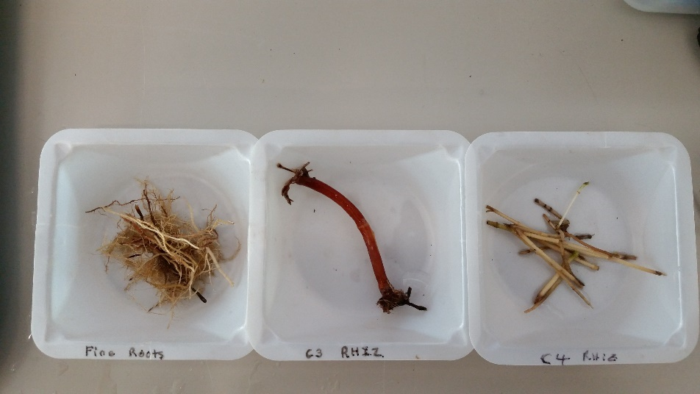

- Phragmites rhizomes are large and easily identifiable (see below). These should only be found in the root cores extracted from the Phrag Experiment.
  - The left photo of a Phragmites rhizome has Fine Roots growing off of it. Those should be removed and placed with Fine Roots
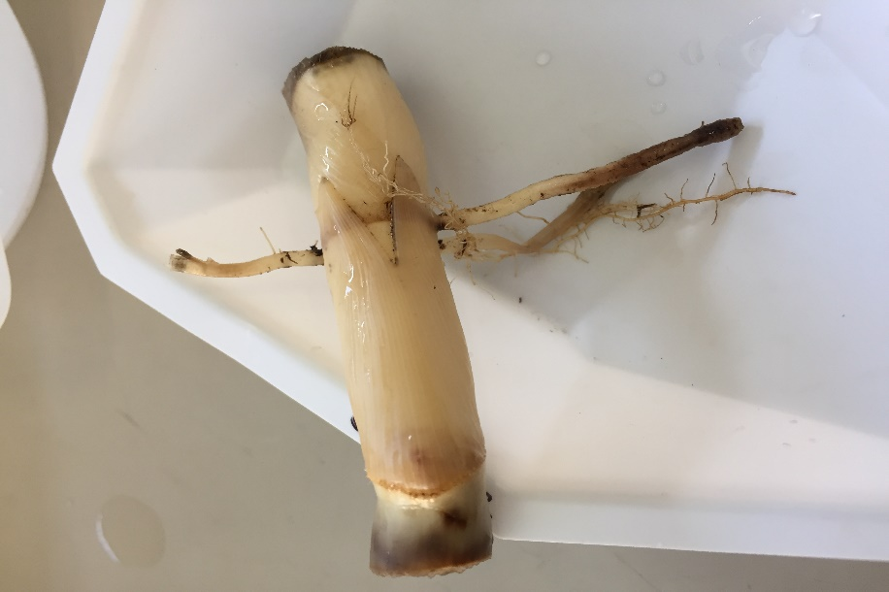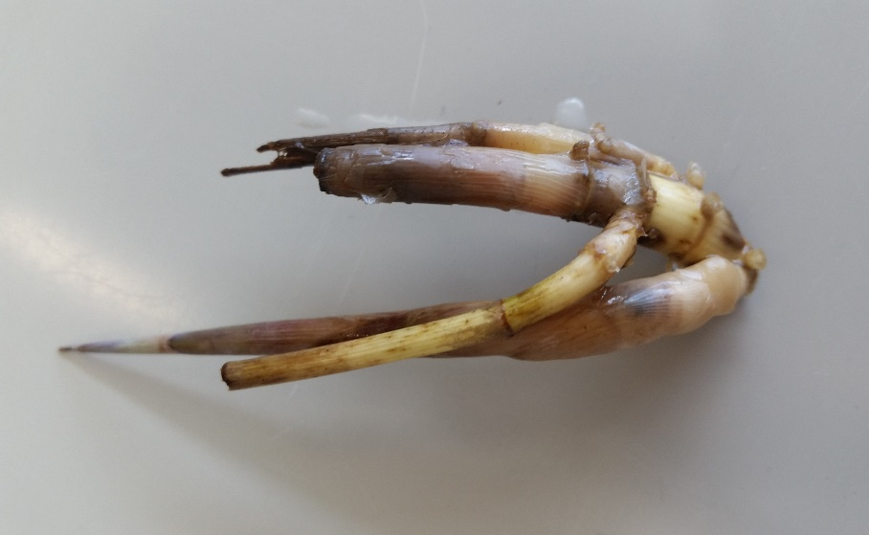
Also specific to the Phrag Experiment is the possibility of “Other Rhizomes” from various species that are common in those experimental chambers.

- Label the appropriate number of coin envelopes as follows:

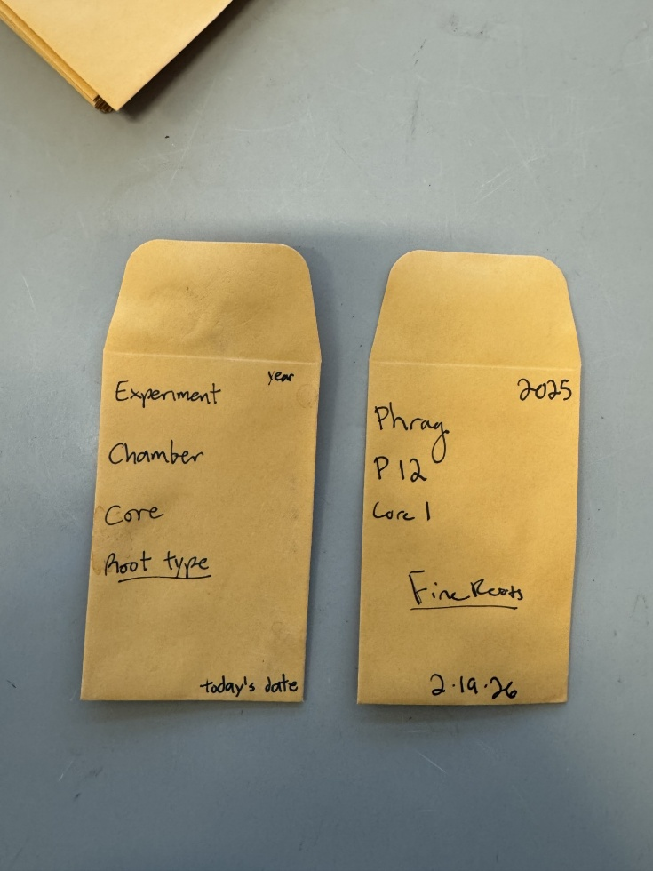
Year
Experiment
Chamber/Plot
Core #/Letter
Root/Rhizome type
Sorting date

- Place each type of root/rhizome in its corresponding envelope.

- Initial, date, and mark off each type of root/rhizome collected on the Sorting Checklist.

- Place root envelopes in a box labeled with the Experiment, Year, Lab and information on a person to contact in case other users of the room have questions.

- When finished sorting for the day, place the box of sorted roots in to the grieve oven.

  - All samples should be dried in the grieve oven at 60°C for at least 72 hours before moving on to the weighing stage.

- Rince out the Ziplock bags and use the glassware drying racks to hang-dry the labeled Ziplock bag. These bags get reused each year.

- Once all bags from an experiment have been cleaned and dried, organize them according to chamber and core number, then use a sharpie to refresh any labels that need it. Afterwards, SMARTX bags can be stored in the appropriately labeled box in Rm 1029. LTREB bags will need to be taken back to GCReW for next year.

Add an appendix, and/or a powerpoint, with images of different roots and sorting advice

Weighing Methods
Weighing below ground root samples is done in the Field Sample Processing Room, Mathias 1028. Make sure that you sign out a workstation and a balance in this room on Cluster Market, prior to your expected day(s) of use. All samples should have been dried at 60°C for at least 72 hours before moving on to this stage of ingrowth processing.
Materials:
- Balance (located in Rm 1028)
- Weigh boat(s)
- Standards (1g & 50g)
- Static gun
- Tweezers
- Datasheet(s)
- Pencil
- Samples

Prior to Weighing
- Print the appropriate data collection sheet(s) for a given experiment.
1M Mass Data Collection Sheet
2M Mass Data Collection Sheet
Phrag Mass Data Collection Sheet
SMARTX Mass Data Collection Sheet

- Remove samples from drying oven. Make sure samples reach room temperature before weighing them (about 20 minutes).

- Turn on the balance 10 minutes prior to starting. Level the balance before use. Check to see if the balance bubble is within the level circle. Adjust as needed.

- Weigh and record the mass of 1g, 50g, and 100g standards. Be sure to weigh the standards each new day when using the balance. The balance doors must be closed to reach an accurate, stable reading.

Weighing Protocol
- Place weigh boat on the plate and tare it to zero. The balance doors must be closed when zeroing.
Tip: Use static gun when the reading is bouncing around and not reaching a stable weight reading.

- Remove the weigh boat from the balance and place dried sample in the boat. Check to ensure that the entire sample is removed from coin envelope.

- Place weigh boat with sample back on balance plate.

- Record weight on datasheet (to 3 decimal places). Round the 4th decimal place half up/down.

- Return the weighed sample to its coin envelope, or to a compiled/consolidated envelope. (See below Consolidating instructions.)

- Remove all leftover particles from weigh boat using a Kim wipe.

- Repeat steps 1-6 for all samples.

- When all weights are recorded, scan the datasheet(s), to be saved under the appropriate Experiments’ folder.
Tip: Look at previous years organization if you are confused about how to do this.

- Transcribe the data into the existing Census year data spreadsheet(s) located in the Experiments’ folder.

Consolidating the Samples
Once the samples have been weighed, they will likely have to be consolidated before proceeding to the grinding stage. Consolidating, or compiling, root samples is done in the Field Sample Processing Room, Mathias 1028. Make sure that you sign out a workstation in this room (on Cluster Market) prior to your expected day(s) of use.
Tip: It may be more efficient to integrate the consolidation process into the weighing process, consolidating the samples by chamber right after they have been weighed.
Be mindful that the way in which the samples are consolidated is different for each experiment as such:
1M
Samples are consolidated by root type per chamber. For example, in Chamber Sp1E, the Fine Roots from all three root cores from Chamber Sp1E can be combined into one envelope.

2M
Samples are consolidated by root type per chamber. For example, in Chamber 2, C3 Rhizomes from all three Chamber 2 root cores can be combined into one envelope.

PHRAG
For each chamber, consolidate cores 1-3 and cores 4-6 by root type. This is to accommodate the interest in the native vs. Phrag portions of the chamber. For example, in Chamber 1, the Fine Roots from cores 1-3 are consolidated into one envelope while the Fine Roots from cores 4-6 will be consolidated into a second envelope. Make sure to label these envelopes correctly.

SMARTX
Weigh each coin envelope INDIVIDUALLY first. Once weighed, consolidate/compile appropriately and ALWAYS within the same plot. It is up to the individual to do this after weighing or prior to grinding.
- Compile Top and Bottom sections of each core together. We do not differentiate after weighing.
- Compile fine roots of cores 4 and 6 together, C3 Rhizomes of cores 4 and 6 together, and C4 Rhizomes of cores 4 and 6 together. Do NOT compile core 8 with 4 and 6 (core 8 was enriched with nitrogen therefore it will be analyzed separately for C and N data).

Labeling Scintillation Vials
Prior to grinding ingrowth root samples, scintillation vials must be labeled and organized. It is in these vials that the ground or small samples will be put. This is a task that can be done in your office space and does not require the reservation of a shared workspace. (This process will take one person the better part of a day.)

Materials:
- Sorting Checklists
- Pencil
- 20 mL Scintillation vials
- Waterproof address labels
- Thin-tipped Sharpie
- Color printer

Labeling Protocol
- Start by opening the vial labelling document(s) and printing those labels (on a color printer) on weatherproof address label sheets. (Links below) Note: These documents contain ALL possible labels necessary for each individual Experiment. Print ALL labels but realize that not all of the labels will be used for any given year. If you wish to take the time to select only the applicable labels, you may do so. It is time-consuming, but it does save paper and ink.
1M Labels
2M Labels
Phrag Labels
SMARTX Labels

- Use the Mass Data Collection Sheet to figure out which root types (fine root, C3, C4, Phrag Rhiz) were found in each Chamber/Plot. Be mindful of how each Experiment has consolidated their samples. Samples of the same root type have been combined for each Chamber/Plot according to the individual Experiments’ consolidation protocols.

- Cross-reference the Sorting Checklist(s) with the pre-printed labels, going through each Chamber/Plot individually, and finding and applying the necessary labels for each root type present in that Chamber/Plot. Do not put labels on vials where there was no sample collected for that root type. Remember, not all of the labels will be used.

4.After the label has been adhered to the vial, use a thin-tipped Sharpie to hand label the cap of the vial with the appropriate information (as shown below), using the vial label as a reference. Tip: It may be more efficient to label the caps at the same time as you apply the label to the vial, but it can also be done after you have applied all of the labels.
Please note that not all samples will be ground, see below for rules. Add a star or asterisk to the top of the vial to denote this.
  - For Fine Roots, C3 or Phrag Rhiz that do not have a consolidated total weight of 0.030g or 30mg, the sample will be placed directly into the vial as these samples are too small for the grinding process.
  - For C4, the consolidated total weight must be over 0.040 g or 40 mg.

Plot/Ch# Root Type

SP1E Fine Roots

Example

5.Continue to go through each Chamber/Plot, one at a time, adding the applicable labels to vials and labeling the caps as you go. Put vials back into the box, in order by Chamber/Plot.

- For vials with small amounts of sample that will not be ground

SP1E Fine Roots

Grinding Methods
Grinding ingrowth root samples is done in the Field Sample Processing Room (Mathias 1028) and the Grinding Room (Mathias 1028A). Make sure that you sign out a workstation in/access to these rooms (on Cluster Market), prior to your expected day(s) of use.
The grinding process is visually portrayed very nicely in a Powerpoint presentation (link below). A printed copy of this Powerpoint should also be accessible near the grinding machine.
Powerpoint: S:\Biogeochemistry\Methods & Procedures\Harvest Sample Grinding Protocol\2020 Harvest Sample Grinding Protocol.pptx
Materials:
- Funnel (1.5cm d.)
- Tweezers
- Datasheet
- Grinding Checklist(s)
- Pencil
- Samples
- Labeled Scintillation vials
- Coffee grinder
- Kimwipes
- DI water
- Ethanol
- Paint brush
Prior to Grinding
- Organize consolidated/compiled sample coin envelopes to correspond with the order of the labeled sample scintillation vials.
- Check each coin envelope to see how much sample is inside.
  - If necessary, use scissors to cut roots/rhizomes into smaller pieces, or for larger samples use the coffee grinder. The coffee grinder will have to be cleaned between each use. Insert how to clean the coffee grinder?
  - If the sample will not be ground as it is weights less than the minimum standards set in the scintillation vials labeling protocol above, then place the sample directly into its scintillation vials. The vial should already be marked with an asterisk/star on the cap, if not, do so.
- Print Grinding checklist to keep track of progress as samples are processed. Use the Sorting Checklist(s) to make the Grinding checklist applicable to this season.

S:\Biogeochemistry\GCREW\0-GCREW Operations\GCREW Methods & Protocols\Root Ingrowth\Checklist

S:\Biogeochemistry\GCREW\0-GCREW-Wide Data\Root Wash Techs\Step 5 - Grinding

Grinding Protocols
- Prior to starting find 4 stainless steel capsules next to grinder; remove O-ring from the lids; scrub O-ring, capsules, and other equipment with Ethanol to remove any sample traces from other experiments. Lay a paper towel out on the counter to establish an area for “clean” equipment. After scrubbing everything with ethanol rinse thoroughly with DI and dry with Kim Wipes.

- Open the lid of the grinder and inspect the belt. Look that it’s set on the track and there is no dry rot to or nicks in the belt. Look at ball joints where the capsules spin. Look for rust and move the joint around with your hands feel for resistance. If there is rust or resistance, spray joints with WD-40 and move them around.

- Turn on switch located on the back panel on the lower right corner. Set the time to 7 minutes 30 seconds.

- Take out two vials from the box and match with two capsules. The matching vials and capsules should never separate.

- Fill capsules ¼ or less full, removing excess sample as needed. Secure the lid tightly and put capsules into the mixer mill, with their corresponding vials placed on either side of the mixer.
Note: If capsule is too full the root material will not grind to fine powder.

- Tighten the gears and black stoppers to secure the capsules. Make sure that they are immobile.
- Close the lid of the mixer mill and hit the start button. While samples are in the mixer mill listen for sounds that may indicate the capsule has loosened. Be prepared to hit the stop button or cut the power by flipping the switch in the back.

While one set is grinding, start processing the previous set of samples and start preparing the next set of samples to be ground.
- Remove capsules from the mixer mill once the cycle is complete, keeping the vials with their corresponding capsules. The matching vials and capsules should never separate.
- Open the capsule and remove the metal balls carefully with tweezers. Set them on the lid.
- Set the funnel on top of the corresponding vial.
- Upend the capsule and shake it into the funnel, losing as little sample as possible.
- Use the paint brush as necessary to extract small amounts of sample stuck to the capsule walls and lid, and continue funneling sample into the vial. Brush sample stuck to the funnel into the vial at the end.
- Close the vial and return it to the box.
Cleaning Post-grinding
- Replace metal balls into jar.
- Squirt ~2cm of DI water into the jar, hold the lid closed, and shake.
- Pour out the water into the waste jar, making sure the balls don’t fall out.
- Wipe the capsule out with a paper towel; wipe the lid also.
- Squirt ~2mm of ethanol into jar and thoroughly wipe with paper towel; wipe the lid also.
- Dry the inside of the jar of any remaining DI water & ethanol
- Wipe tweezers, paintbrush, the counter, and your gloves down with ethanol.
- Squirt ethanol into the funnel above the waste jar and then wipe thoroughly.
- After the final grinding cycle, remove the O-rings and once again clean them separately.

Tinning Ground Samples for CHN Protocol
Tinning Protocol

- Grab clear 96 well microplate tray and lid from CHN drawer in BGC lab, Kim wipe.

- Print stable isotope mass spec spreadsheet. Make sure the template has the most up to date standards being used at Suitland.
  - SMARTX uses separate datasheets and trays for N-enriched samples and non-enriched samples.

S:\Biogeochemistry\GCREW\0-GCREW-Wide Data\Root Wash Techs\Step 6 – Tinning

- If you are adding to an existing tray, grab the tray and corresponding datasheet.

- Use the designated tinning station in the first floor Terrestrial Ecology lab. You must reserve the station in advance on Cluster Market. (Terrestrial Guild-Mathias 1062-Microbalance)

- Brush off weigh circle on balance with paint brush.

- On datasheet, record SI_ID: eg 2019_1, etc. and sample identifier (sample label). The identifier will generally include the year, the experiment, any subsets or chambers, and the biomass type.
Example: 2022_1M_Sp_3C_FineRoots, or 2022_SMARTX_320(1-3)_SPPA

- Sterilize spoon, glass “donut”, and forceps with ethanol on Kim wipe.

- Turn on the microbalance (press the On button on the lower right).

- Place an empty tin weigh boat on the scale and hit ReZero (check for bubble icon on balance to appear and disappear)
  - Tin size is 9x5mm

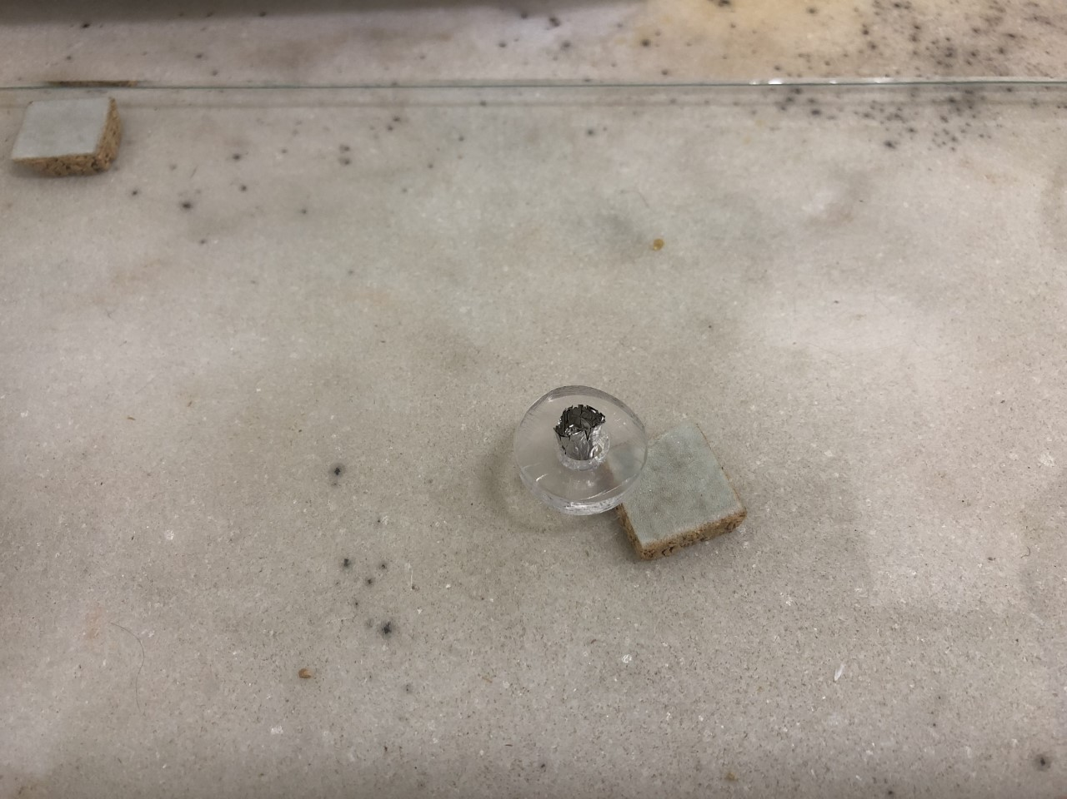
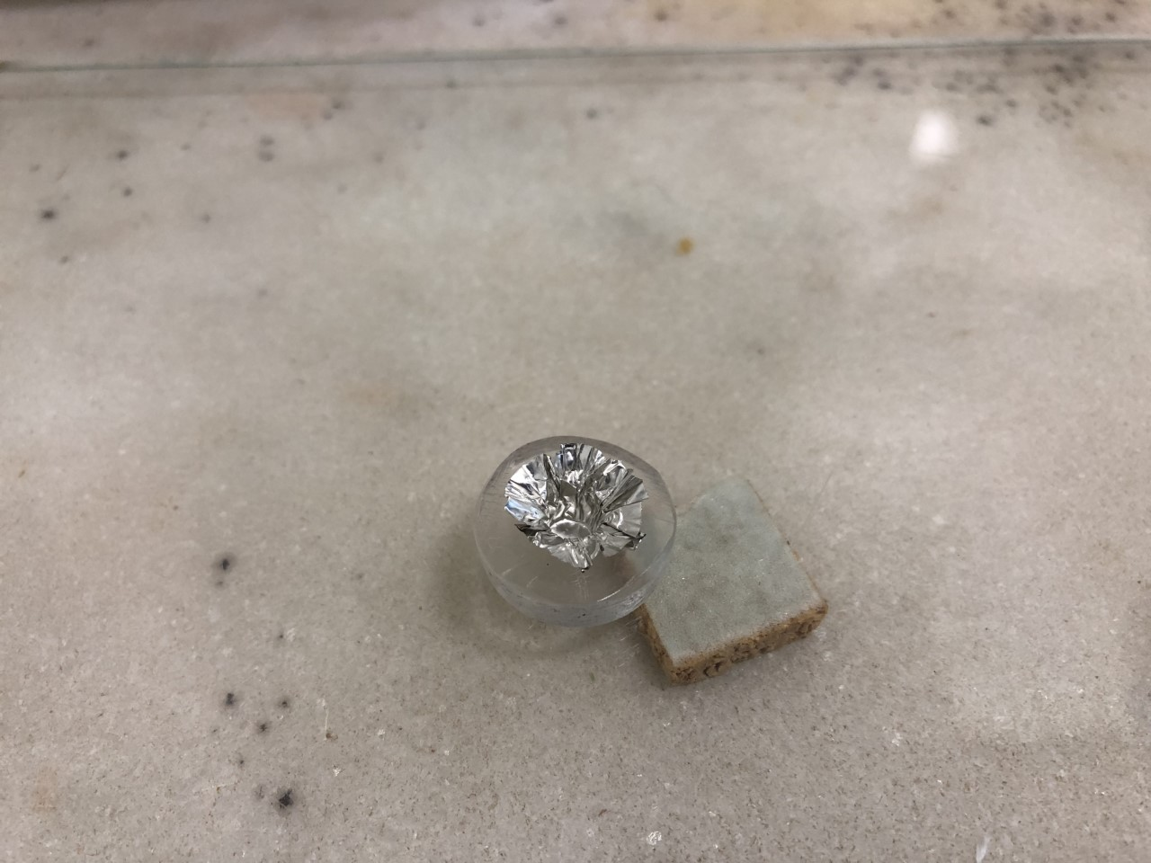
- Place weigh boat in glass “donut”, open up the top of the boat in both directions with forceps.

- Add ~2 scoops plant material (large spoon: 1 heaping spoonful, 1 normal spoonful).
  - The scint vials often have a lot of static that makes it difficult to scoop material out of them; be cautious of this when scooping.

- Place on balance

- Add/reduce material until it reads 12-13 mg.
  - Something between 11.9__ to 13.0__ is acceptable within the margin of error, but always try to stay comfortably within 12-13.

- THE ROLL: flatten weigh boat at the top with the forceps, squeezing all the air out without touching the bottom where the plant material is, bring two fan ends together, flatten again, roll twice with ends of forceps, flatten hard between body of forceps, smooth the flattened wings.
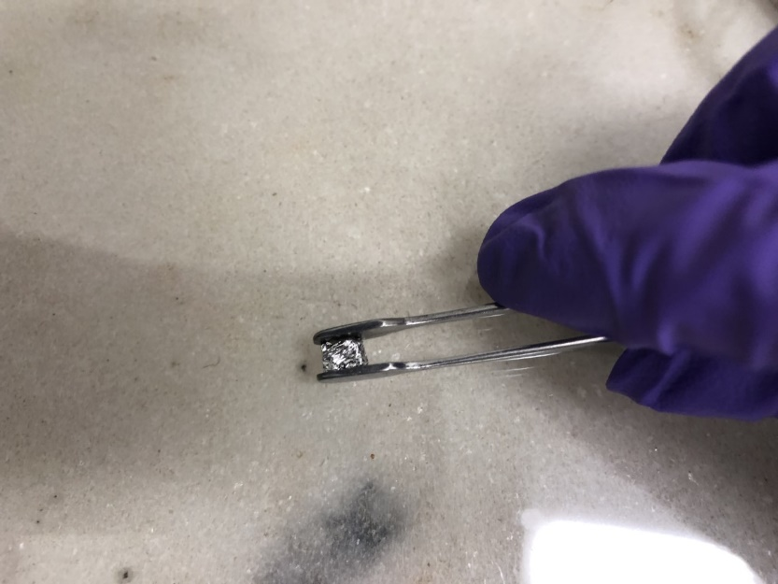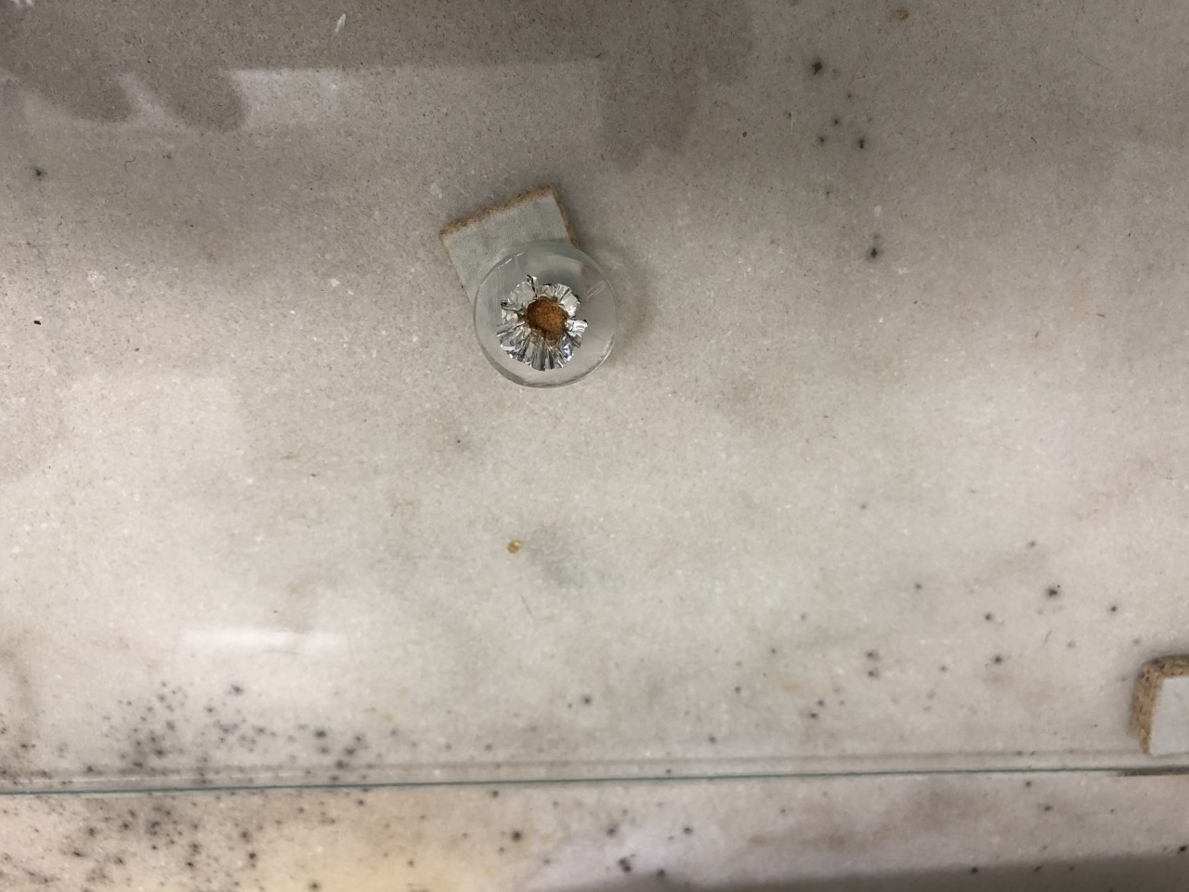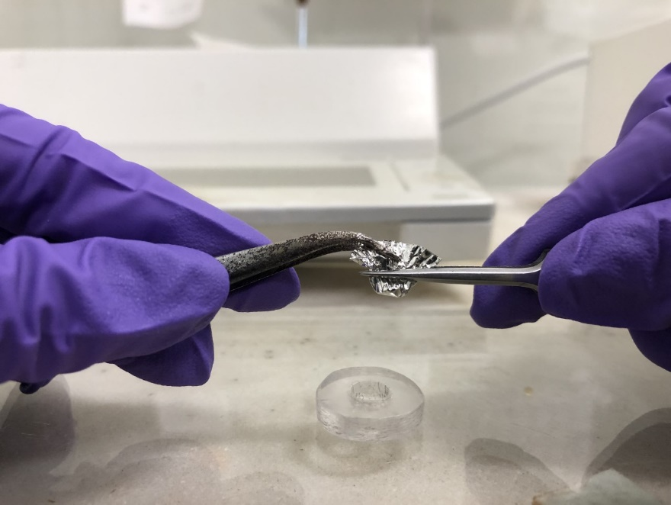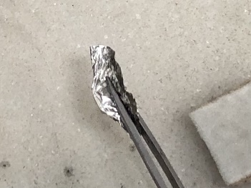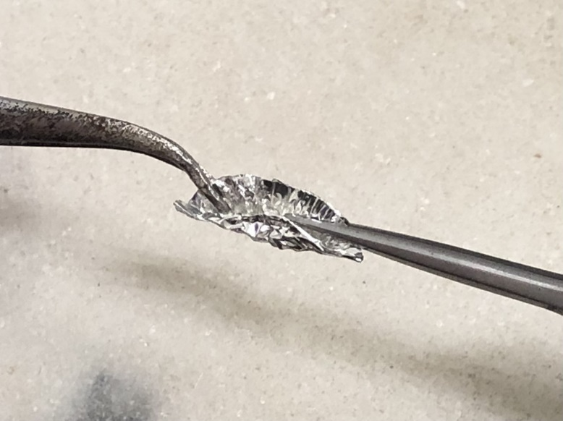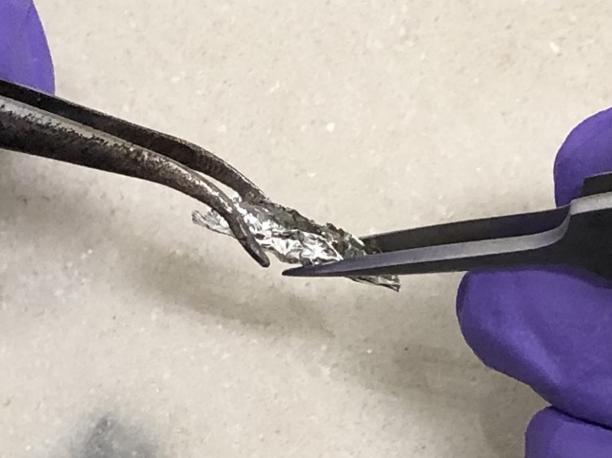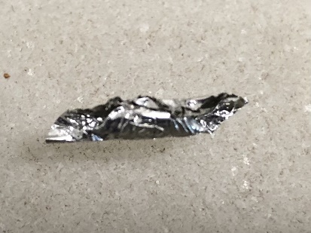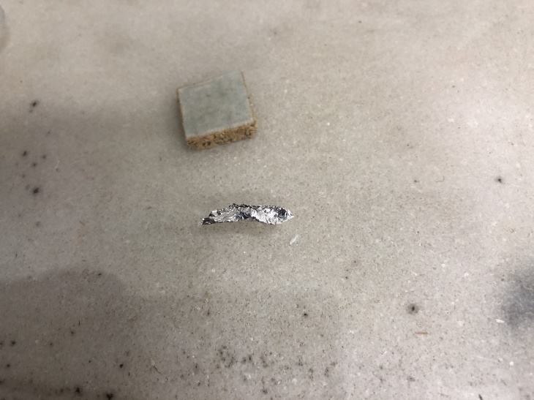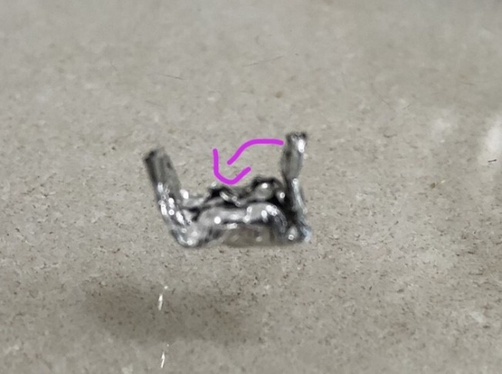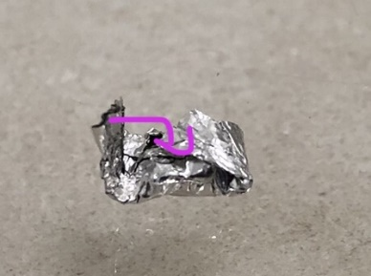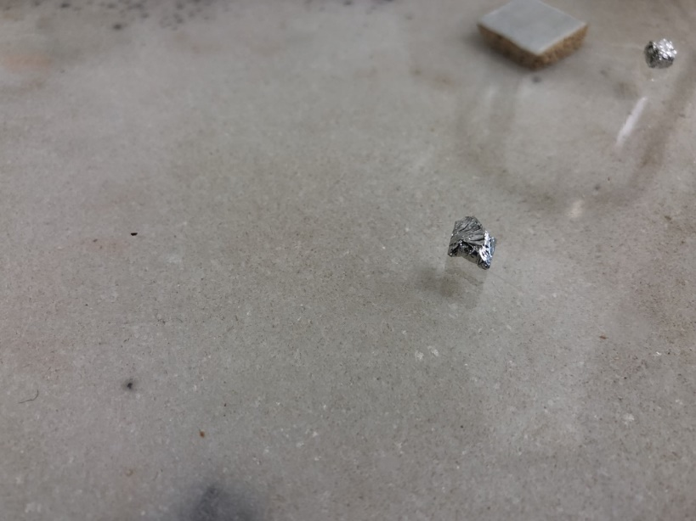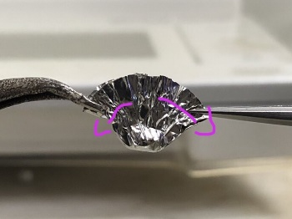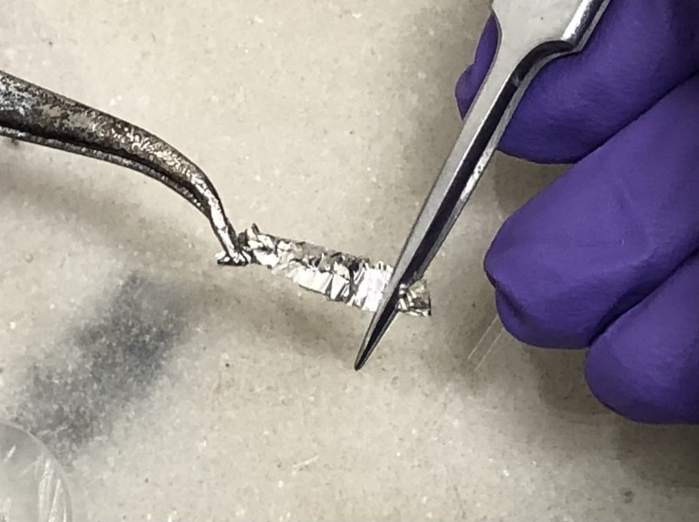
The tips of the forceps can puncture the pellet with too much force, and pulling or bending too much along a fold can split the seam. Look for any place on the pellet where the color of the powder is visible.

9. Fold both wings toward the center, making a U shape
10. Fold one side down (starting with the shorter wing is easier)
11. Fold down the second wing
12. Flatten and squish the sample from all sides until it can fit easily in a micro-well plate
5. Fold again
6. fold or press the edge down
7. Flatten one side into a “wing”
8. Repeat
1. Weigh boat with sample
2. Pull edges apart
3. Flatten to remove the air
4. Grasp weigh boat just above the sample with forceps then press against the table to fold

- Return pellet to balance and hit Select 1 or Select 2 (for right-handed and left-handed users, respectively) to read the weight.
  - The Select 2 side currently opens fine but stutters and sometimes gets stuck when closing. The problem may be in the motor.
- Record under Sample (mg) on sheet (check for bubble to indicate the reading is stable). Double check that the vial label and the sample name match.

- Place pellet in correct well.
  - The pellet needs to be small enough to lay flat on the bottom of the well without getting stuck on the sides.
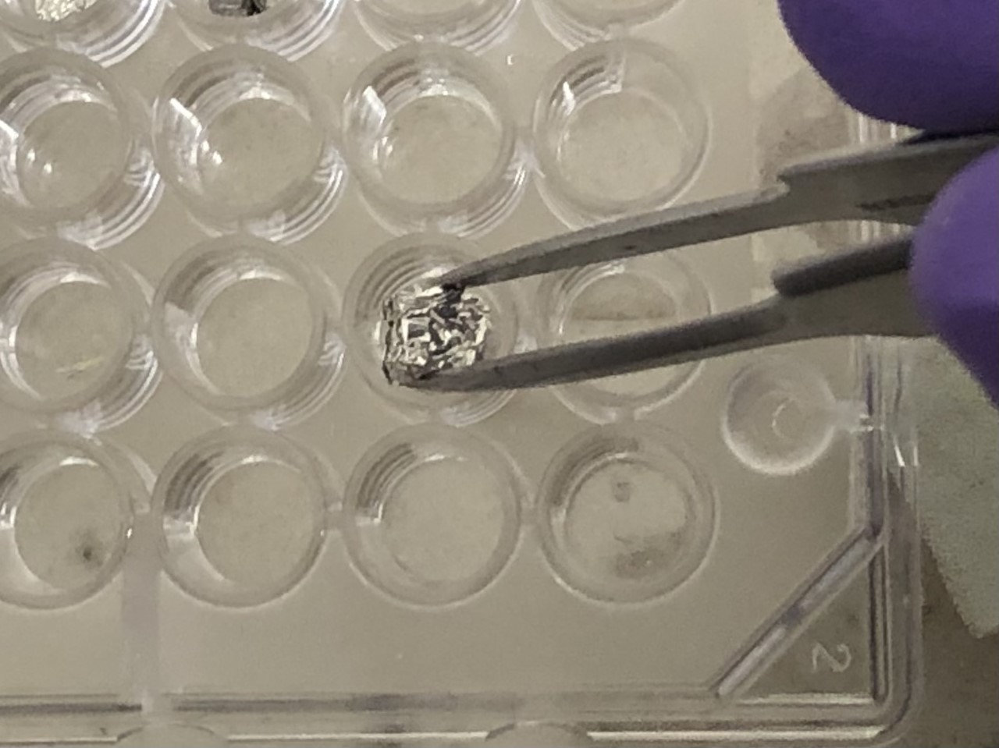

- Place sample bottle face down in box space.

- Sterilize all tools and workspace between every sample.

- After the very last run, clean out balance trays (dump plant material and wipe with ethanol)

- Turn the balance off by lifting the bar up.

Tips
**If not enough sample to reach 12-13mg, skip sample but note on a separate list

**Leave spaces for the blanks and standards in the tray, following the order in the datasheet

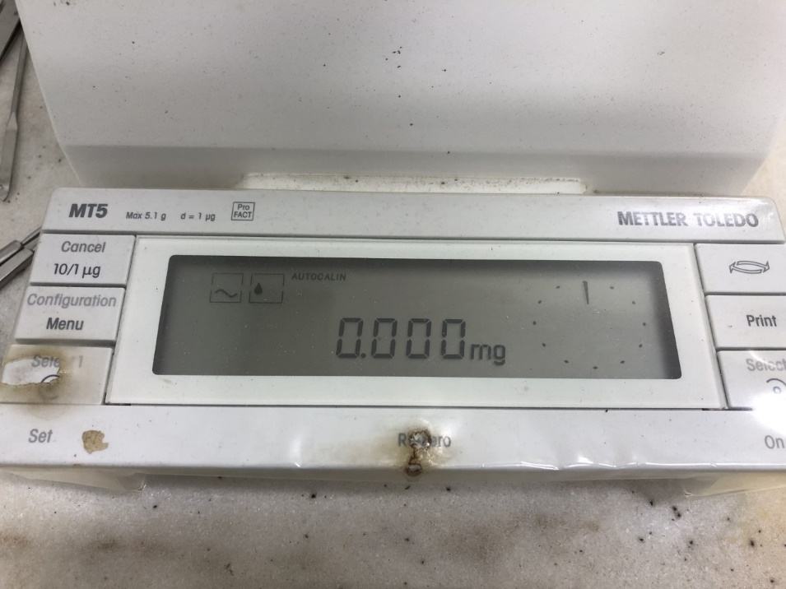
To Calibrate the microbalance:
1
2

- Hit CONFIG button

- When the screen reads CAL INT, hit ReZero

- The calibration will occur automatically. Do not touch the scale until it is done.

- Calibrate before starting any tinning and do so periodically if you will be tinning many samples over several days.

- Sometimes the balance will beep and AUTOCALIN will appear on the screen. Calibrating will remove this message; however, it may disappear on its own.

Data Sheets, Checklists and Labels

All information needed for Root Techs should be consolidated in the Root Tech Folder. Please add links or information to this folder to make it as helpful of a resources as possible.

Folder Pathway
S:\Biogeochemistry\GCREW\0-GCREW-Wide Data\Root Wash Techs

Datasheets

Weighing:

Filepath: S:\Biogeochemistry\GCREW\0-GCREW Operations\GCREW Methods & Protocols\Root Ingrowth\Root Mass Data Templates

1M: S:\Biogeochemistry\GCREW\1-CO2xCommunity Experiment\1-Plant Biomass & CN Data\Root Biomass Data\1M Blank Weighing sheet.xls

2M: S:\Biogeochemistry\GCREW\2-CO2xN Experiment\1-Plant Biomass & CN Data\Root Biomass Data\Data Sheet for writing weights\2M Blank Weighing sheet.xls

Phrag: S:\Biogeochemistry\GCREW\3-PhragmitesxCO2xN Experiment\1-Plant Biomass & CN Data\Root Biomass Data\Phrag Blank Weight Datasheet.xls

SMARTX: S:\Biogeochemistry\GCREW\4-SMARTX\3-Data\1-Plant biomass & CN data\Root Biomass Data\Data Sheet for writing weights\SMARTX Root Ingrowth Biomass Datasheet.xlsx
Checklists

Washing:

Filepath: \\Si-sercfs01\serc\Shared\Biogeochemistry\GCREW\0-GCREW Operations\GCREW Methods & Protocols\Root Ingrowth\Checklist
LTREB (1M/2M/Phrag): \\Si-sercfs01\serc\Shared\Biogeochemistry\GCREW\0-GCREW Operations\GCREW Methods & Protocols\Root Ingrowth\Checklist\Checklist for washing 1M 2M Phrag.xlsx
SMARTX: S:\Biogeochemistry\GCREW\0-GCREW Operations\GCREW Methods & Protocols\Root Ingrowth\Checklist\GCREW SMARTX - checklist for root washing.xlsx
Sorting:
Filepath: S:\Biogeochemistry\GCREW\0-GCREW Operations\GCREW Methods & Protocols\Root Ingrowth\Checklist
LTREB: S:\Biogeochemistry\GCREW\0-GCREW Operations\GCREW Methods & Protocols\Root Ingrowth\Checklist\Rootcore sorting checklist (1M 2M Phrag)
SMARTX: S:\Biogeochemistry\GCREW\0-GCREW Operations\GCREW Methods & Protocols\Root Ingrowth\Checklist\Rootcore sorting checklist (1M 2M Phrag).xlsx
Grinding:
Filepath: S:\Biogeochemistry\GCREW\0-GCREW Operations\GCREW Methods & Protocols\Root Ingrowth\Checklist

1M: S:\Biogeochemistry\GCREW\0-GCREW Operations\GCREW Methods & Protocols\Root Ingrowth\Checklist\1M_Ingrowth_Grinding_Checklist(working)

2M: S:\Biogeochemistry\GCREW\0-GCREW Operations\GCREW Methods & Protocols\Root Ingrowth\Checklist\2M_Ingrowth_Grinding_Checklist(working)

Phrag: S:\Biogeochemistry\GCREW\0-GCREW Operations\GCREW Methods & Protocols\Root Ingrowth\Checklist\2M_Ingrowth_Grinding_Checklist(working)

SMARTX: S:\Biogeochemistry\GCREW\0-GCREW Operations\GCREW Methods & Protocols\Root Ingrowth\Checklist\GCREW SMARTX – checklist for root grinding

Labels

Parent Filepath: S:\Biogeochemistry\GCREW\0-GCREW Operations\GCREW Methods & Protocols\Root Ingrowth\Grinding Labels

1M: S:\Biogeochemistry\GCREW\0-GCREW Operations\GCREW Methods & Protocols\Root Ingrowth\Grinding Labels\1M Root Core Labels.doc

2M: S:\Biogeochemistry\GCREW\0-GCREW Operations\GCREW Methods & Protocols\Root Ingrowth\Grinding Labels\2M Root Core labels.doc

Phrag: S:\Biogeochemistry\GCREW\0-GCREW Operations\GCREW Methods & Protocols\Root Ingrowth\Grinding Labels\Phrag Root Core labels.doc

SMARTX: S:\Biogeochemistry\GCREW\4-SMARTX\2-Protocols, labels, datasheets\Labels\2020\SMARTX 2020 belowground vial labels.doc

